**Statistical Report Writing Sample No.4**

**Introduction.** Cuckoos place their eggs in other birds' nests for hatching and rearing. Several observations indicate that cuckoos choose the “adoptive parents” carefully, such that the cuckoo eggs are similar in size and appearance to the eggs of the adoptive species. In order to examine this further, researchers investigated 154 cuckoo eggs and measured their size ([Latter, 1905](http://e.pub/vsaknoohmscav5hpi6za.vbk/OPS/loc_015.xhtml#eid17657)). The unit is half millimeters. The width of the eggs ranges from 30 half millimeters to 35 half millimeters. The eggs were adopted by three different species: wrens, redstarts, and whitethroats. The distribution of eggs of different sizes is given for each adoptive species in the table.

|  |  |  |  |  |  |  |
| --- | --- | --- | --- | --- | --- | --- |
|  | Width of egg (half mm) | | | | | |
| Species | 30 | 31 | 32 | 33 | 34 | 35 |
| Wren | 3 | 11 | 19 | 7 | 10 | 4 |
| Redstart | 0 | 5 | 13 | 11 | 6 | 1 |
| Whitethroat | 2 | 2 | 17 | 19 | 22 | 2 |

In this study we want to determine whether the width of eggs from different species differ or not.

**Data analysis.**  The parallel boxplots below are used to see any difference among species visually. While eggs from redstart show the smallest variation, the variances are not different among species. The highest median is observed for the group of whitethroat.

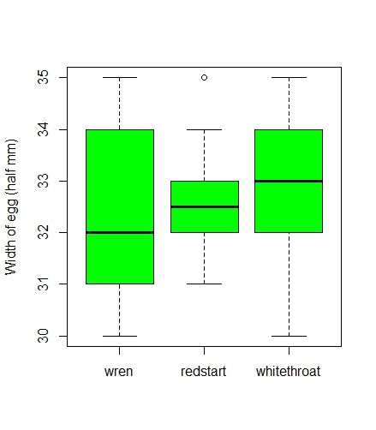

In data analysis we consider a linear model for the width Yi of i-th subject, and identify the following formula

Yi = αgroup(i) + εi

where the parameter “αgroup(i)” indicates the average width of eggs from the “group(i)” of the i-th subject. The residual εi is assumed to be normally distributed with common variance σ2. The following plot shows standardized residuals (y-axis) with the estimates (x-axis), 32.41, 32.58, and 32.98, for the parameters α1, α2, and α3 for “wren”, “redstart” and “whitethroat,” respectively. Similarly to the parallel boxplots, this plot indicates the homogeneity of variance.

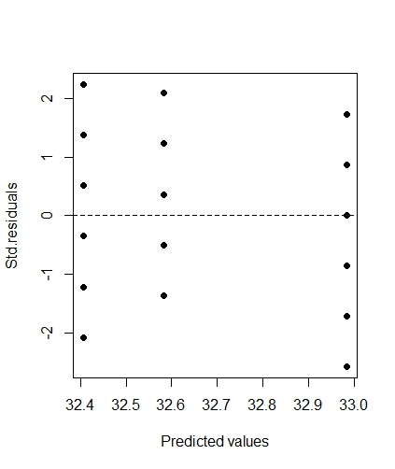

In order to test whether there is any difference among species, we produced the following ANOVA table. The degrees of freedom (df) indicate that the group size k is 3, and that the sample size n becomes 2+151+1 = 154, adding the sizes 54, 36, and 64 respectively of wren, redstart, and whitethroat.

|  |  |  |  |  |  |
| --- | --- | --- | --- | --- | --- |
|  | df | Sum.Sq | Mean.Sq | F-value | p-value |
| species | 2 | 10.268 | 5.1338 | 3.7491 | 0.02576 |
| Residuals | 151 | 206.771 | 1.3693 |  |  |

The null hypothesis

H0: α1 = α2 = α3

was considered, and it was rejected (p-value of 0.026). Therefore, we conclude that there is evidence of difference among species.

**Conclusion.** Our analysis indicated that there was evidence that the width of eggs from different species differs (p-value of 0.026). The 95% confidence intervals (−0.08, 0.88), (−0.32, 0.67), and (0.15, 1.00) were obtained for the pairwise differences α3 – α2, α2 – α1, and α3 – α1, respectively. In particular, the width of wren and whitethroat differs significantly. It should be noted that the lengths of interval differ because the numbers of observations are different among species.