**Statistical Report Writing Sample No.6.**

**Introduction.** A study tried to examine if the amount of food (normal or excessive) influences the risk of feline lower urinary tract diseases (disease and non-disease) in cats.

|  |  |  |
| --- | --- | --- |
| Group | Disease | Nondisease |
| Normal | 8 | 17 |
| Excessive | 42 | 7 |

In the study 50 cats with urinary tract disease and 24 cats without disease were selected. Then they were observed for daily amount of food, and identified as normal or excessive. It should be noted that the study should be considered as retrospective study.

**Data analysis.**  The table and the mosaic plot below display the proportion of cats with urinary tract disease in normal and excessive group, and shows the higher percentage (86%) of cats with disease in the excessive group in comparison with the normal group (32%).

|  |  |  |
| --- | --- | --- |
| Group | Disease | Nondisease |
| Normal | 0.320 | 0.680 |
| Excessive | 0.857 | 0.143 |

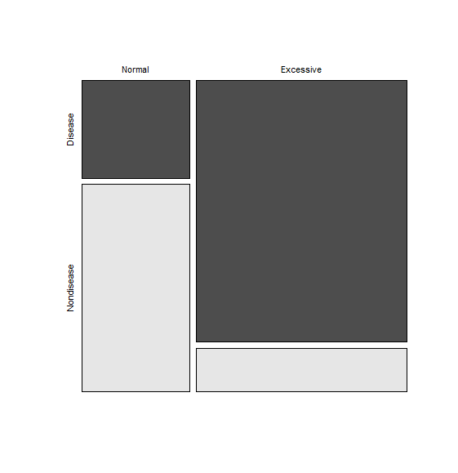

It suggests that the excessive amount of food would increase the risk of feline lower urinary tract disease in cats. This claim can be tested by the comparison of two proportions of cats with disease for normal and excessive group. And the p-value of 0.00001 (which uses the procedure with continuity correction) indicates that the result is highly significant. The 95% confidence interval for the difference in proportion becomes (0.30, 0.77). The same result (the p-value of 0.00001) is obtained by the chi-square test for homogeneity. Fisher’s exact test yields the p-value of 0.000009, which is similarly significant as in the result of chi-square test.

**Conclusion.** The study shows that the proportion of cats with disease for a group of cats eating excessive amount of food is significantly higher than that of normal group. It suggests the relationship between the feline lower urinary tract disease and the behavioral risk of eating and diet.